ASSIGNMENT

Data-Driven Insights for Inventory Optimization at Lotts & Co. Clontarf

strategic analysis using data insights
predict demand and recommendation to minimize stock shortages
- the finding will support decision-making rather than executing inventory changes

While I don’t manage inventory, my analysis can provide actionable insights into optimising stock levels and reducing shortages.

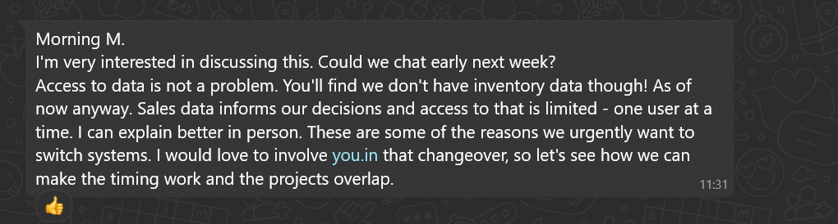
INTRODUCTION
- Goal/ purpose
- Clarifying that the focus is on analysing sales data to predict demand, not on direct inventory control.
- Business Context describes Lotts & Co and the challenge of stock shortages.
PROJECT CONCEPT
- Problem: issues on stock shortages and how it impact sales and customer satisfaction
BUSINESS ANALYSIS METHOD
- SWOT Analysis (Strengths, Weaknesses, Opportunities, Threats)
DATA COLLECTION AND ANALYSIS

